**Main effect, interaction in factorial design, and in crossover design:**

**Factorial design:**

The two main effects are supposed to be independent.

We first evaluate the interaction effect:

1. Use PASS:

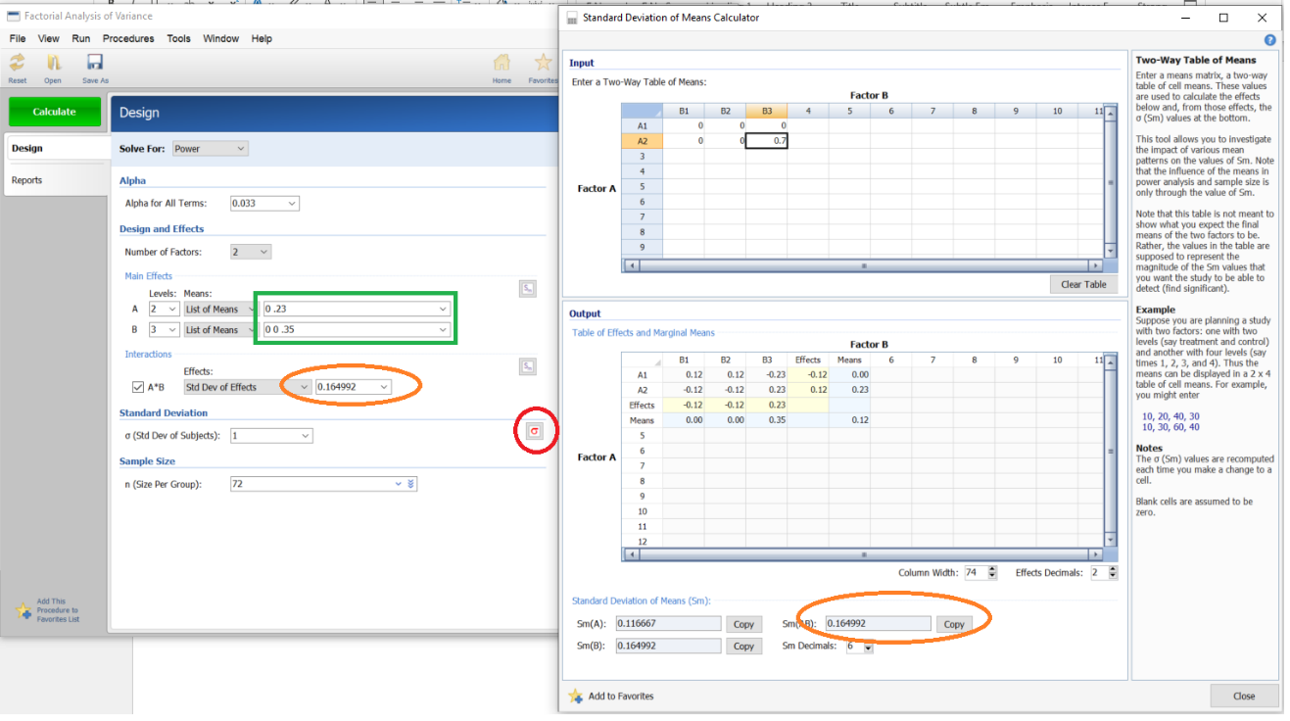

* 1. Input Alpha, Number of factors:
  2. Click on the button circled in red. Two Excel tables will pop up.
  3. Input the means in the table above.
  4. Copy the values highlighted in blue in the table below to the fields enclosed by the green rectangle.
  5. Copy the value encircled by the orange to the field encircled by the orange eclipse.

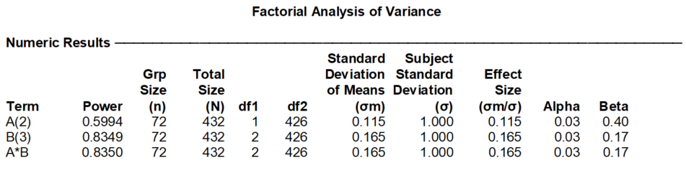

1. Use SAS:

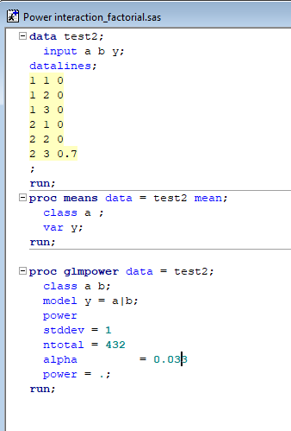

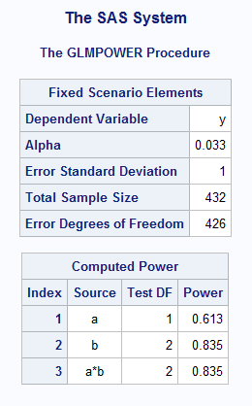

1. Use R simulations:

# Load required package

library(MASS)

# Define simulation parameters

n_sim <- 1000 # Number of simulations

n_per_cell <- round(60*0+ 432/6) # Number of observations per cell (can adjust this for different sample sizes)

alpha <- 0.0167/2 # Significance level

alphai <- 0.033#/4 # Significance level

# Factor levels

A_levels <- c(1, 2)

B_levels <- c(1, 2, 3)

# Define means for the cells

EA=.3

mu_A1_B1 <- 0

mu_A1_B2 <- 0

mu_A1_B3 <- 0

mu_A2_B1 <- EA

mu_A2_B2 <- EA

mu_A2_B3 <- EA+.7 # Includes the interaction effect (+0.4)

mu_A2_B3AB <- EA # NOT includes the interaction effect (+0.4)

# Standard deviation (assuming equal for simplicity)

sigma <- 1

# Power simulation

power_sim <- function() {

p_values <- numeric(n_sim) # Store p-values from each simulation

Ap_values <- numeric(n_sim) # Store p-values from each simulation

Bp_values <- numeric(n_sim) # Store p-values from each simulation

for (i in 1:n_sim) {

# Simulate data for each cell

data <- data.frame(

A = rep(A_levels, each = 3 * n_per_cell),

B = rep(rep(B_levels, each = n_per_cell), 2),

Y = c(

rnorm(n_per_cell, mean = mu_A1_B1, sd = sigma),

rnorm(n_per_cell, mean = mu_A1_B2, sd = sigma),

rnorm(n_per_cell, mean = mu_A1_B3, sd = sigma),

rnorm(n_per_cell, mean = mu_A2_B1, sd = sigma),

rnorm(n_per_cell, mean = mu_A2_B2, sd = sigma),

rnorm(n_per_cell, mean = mu_A2_B3, sd = sigma)

)

)

dataAB <- data.frame(

A = rep(A_levels, each = 3 * n_per_cell),

B = rep(rep(B_levels, each = n_per_cell), 2),

Y = c(

rnorm(n_per_cell, mean = mu_A1_B1, sd = sigma),

rnorm(n_per_cell, mean = mu_A1_B2, sd = sigma),

rnorm(n_per_cell, mean = mu_A1_B3, sd = sigma),

rnorm(n_per_cell, mean = mu_A2_B1, sd = sigma),

rnorm(n_per_cell, mean = mu_A2_B2, sd = sigma),

rnorm(n_per_cell, mean = mu_A2_B3AB, sd = sigma)

)

)

# Convert factors for A and B

data$A <- factor(data$A)

data$B <- factor(data$B)

# Fit a linear model with interaction term

model <- lm(Y ~ A * B, data = data)

modelAB <- lm(Y ~ A + B, data = dataAB)

# Extract p-value for interaction term

A_p_value <- anova(modelAB)[[5]][1]

B_p_value <- anova(modelAB)[[5]][2]

interaction_p_value <- summary(model)$coefficients["A2:B3", "Pr(>|t|)"]

interaction_p_value <- anova(model)[[5]][3]

# Store the p-value

p_values[i] <- interaction_p_value

Ap_values[i] <- A_p_value

Bp_values[i] <- B_p_value

}

# Calculate power (proportion of times the interaction effect is significant)

powerA <- mean(Ap_values < alpha)

powerB <- mean(Bp_values < alpha)

powerI <- mean(p_values < alphai)

return(c(powerA, powerB, powerI))

}

# Run power simulation

#set.seed(123) # For reproducibility

power <- power_sim()

# Output power estimate

cat("Estimated power for testing A effect: ", power[1], "\n")

cat("Estimated power for testing B effect: ", power[2], "\n")

cat("Estimated power for testing the interaction effect: ", power[3], "\n")



1. Another way to do it is that the interaction effect needs 4 times of the sample size required for detecting the main effect of the same magnitude.

This needs to be done using the 3-group calculation. In other words, there are 3 groups, with mean=0, 0 and .7, respectively.

432/3/4=36

Total 432, divided into 3 groups, and then reduced the sample size to ¼.

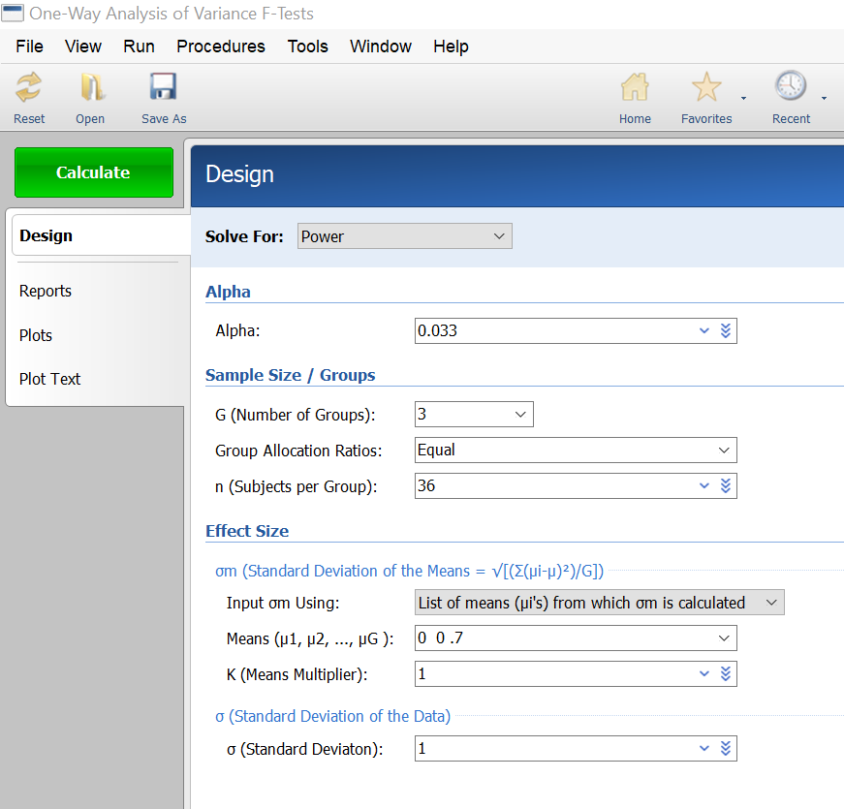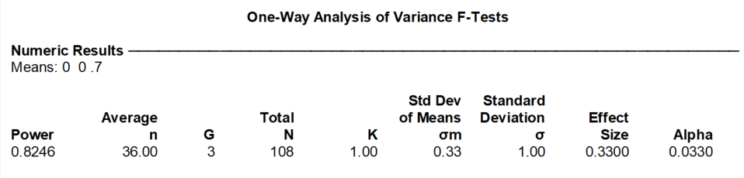

**Crossover design:**

The two main effects are supposed to be independent.